**Lesson Notes**

1. What is the main purpose of an Operating System?

* To recognize computer inputs and hardware
* To recognize and distribute resources
* Creates an easy to use interface in order to produce an easy to access and efficient way of computer use
* Easy to access files, folders, and programs via file management programs
* Allows use of multiple accounts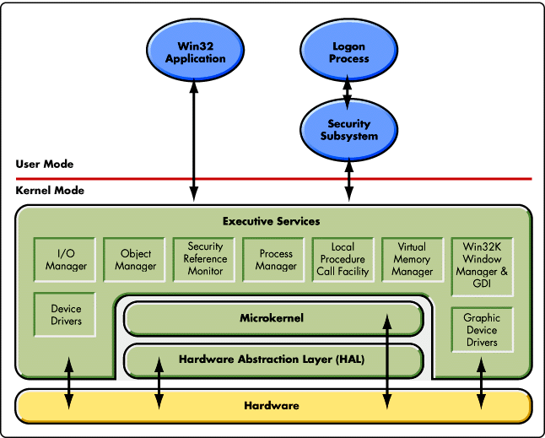

1. What is the difference between Operating System Software and Use Application Software?
2. What is the difference between Operating System Software and Computer Hardware?
3. What are the main parts of an Operating System?
4. What are some popular operating systems?

**Reference Diagram**

**Student Questions**

1. What is a device driver?
   1. Provide a brief summary

A program that checks for a hardware device and controls it.

* 1. List some devices that require a device driver.

Keyboards, Mice, Audio, Display, and a group of other input/output devices

* 1. Provide a label on the reference diagram for the location of a device driver for your graphics card.
  2. Provide a label on the reference diagram for the location of a device driver for a locally attached printer.

1. What is a DLL?
   1. Provide a brief summary

A DLL (or Dynamic-Link Library) is a Windows specific type of file, which can be used in order to load resources and other parts of a program via external files, this can be used to add updates to programs without having to edit the original program

* 1. Explain how DLLs are related to user application programs

They can be used on windows as a way to load all the heavy resources without having to load them one by one

* 1. Provide a label on the reference diagram for the location of a DLL

1. What is a windows manager?
   1. Provide a brief summary

A program that edits your display and shows window/other programs and allows you to work with and edit things in windows

* 1. Explain how a windows manager is related to user application programs

It allows the user to both view and edit windows, in order to produce to whatever needs need to be completed by the user

* 1. Provide a label on the reference diagram for the location of a DLL

1. What is the windows task manager?
   1. Provide a brief summary

It allows you to view a list of all programs currently running, and allows you to force close a majority of them, plus it shows a group of system information in some of its tabs

* 1. List and explain four (4) types of system information provided by the task manager

CPU - Amount of Computer Processing power taken up via the programs on your PC

Memory - Amount of Storage a program takes

Network - Amount of internet being used by the program

Disk - How much RAM is being taken up by a program

* 1. Provide a label on the reference diagram for the operating system components related to each type of information.